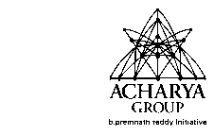
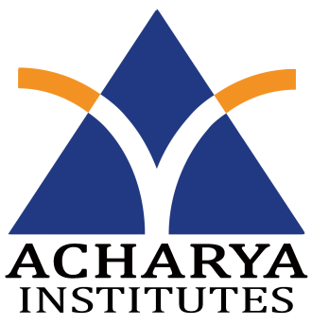
Department of Information Science and Engineering
Acharya Institute of Technology
Acharya Dr. Sarvepalli Radhakrishnan Road,
Soldevanahalli, Bangalore-560107

Date: 21/3/2016
Weekly Project Progress Report

Title of the Project: Android Based Course Delivery and Evaluation System.
Conducted at: Acharya Institute of Technology
Name and USN of the students
1. Bidish Basu, 1AY12IS021
2. Nandan A, 1AY12IS051
3. Vignesh N K, 1AY12IS096
4. Y G Sriram, 1AY12IS100
Name of the Guide: Prof. C K Marigowda
Fourth Week Project Progress report, Dated from 7/3/2016 to 13/3/2016

In the Fourth week we,
- Created the admin web page to enter the details in the database.
- Learnt about the Json parser to connect PHP pages to android application.

Guide signature with Date HOD (ISE Dept.)

